Homework #2
2018110071
Problem 1
Script
clear all;
clc;

x1=fzero(@(x)4*x^3-3*x^2-30,[0,5])
x2=fzero(@(x)3*exp(2*x)-10,[0,1])
x3=fzero(@(x)5*(10^x)-10*x^2,[-1,1])

Result
x1 = 2.2420
x2 = 0.6020
x3 = -0.4307

Problem 2
Script
clear
clc

Function = @(x)(1000*9.8*(4/3*pi*1^3-pi*x^2/3*(3*1-x)))-(4/3*pi*1^3*800*9.8);
height = fzero(Function,[0,2])
fplot(Function)
hold on
plot(height,Function(height),'o','MarkerSize',8)

Result
height = 0.5743
Graph
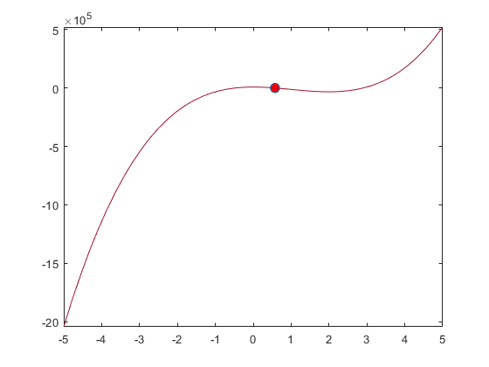

Problem 3
Script
clear
clc

syms t0;
syms t1;
Function = @(x)80*exp(-0.2*t0);
i = int(Function,t0,0,t1);
time = solve(i == 200);

t1 = 15;
water = 400- int(Function,t0,0,t1);

fprintf('time=%f\n',time)
fprintf('water=%f\n',water)

Result
time=3.465736
water=19.914827

Problem 4
Script
clear
clc

Year = [1750 1800 1850 1900 1950 1990 2000 2009];
Population = [791 980 1260 1650 2520 5270 6060 6800];
x=1750:1:2009;
%cftool(Year,Population)

%the exponential function
a = 9.911e-08;
b = 0.01241;
exponential = @(x)a*exp(b*x);

%third-order polynomial
p1= 0.001020697301838;
p2= -5.604096642832609;
p3= 1.025536170980091e+04;
p4= -6.253911927981189e+06;
thirdorder = @(x)p1*x^3 + p2*x^2 + p3*x + p4;

% linear and spline interpolations
linear(x)=interp1(Year,Population,x,'linear');
spline(x)=interp1(Year,Population,x,'spline');

exponential(1980)
thirdorder(1980)
linear(1975)
spline(1975)

figure
hold on
plot(Year ,Population ,'o','Color','r','DisplayName','Origin')
fplot(exponential,[1750 2009],'-','DisplayName','exponential')
legend ('Fontsize',12,'FontWeight','bold')
hold off

figure
hold on
plot(Year ,Population ,'o','Color','r','DisplayName','Origin')
fplot(thirdorder,[1750 2009],'-','DisplayName','thirdorder')
legend ('Fontsize',12,'FontWeight','bold')
hold off

figure
hold on
plot(Year ,Population ,'o','Color','r','DisplayName','Origin')
plot(x,linear(x),'-','DisplayName','exponential')
legend ('Fontsize',12,'FontWeight','bold')
hold off

figure
hold on
plot(Year ,Population ,'o','Color','r','DisplayName','Origin')
plot(x,spline(x),'-','DisplayName','exponential')
legend ('Fontsize',12,'FontWeight','bold')
hold off

Result
exponential = 4.6507e+03
thirdorder = 4.4563e+03
linear = 4.2388e+03
spline= 4.0986e+03
Graph
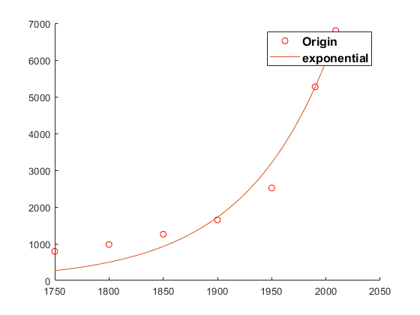
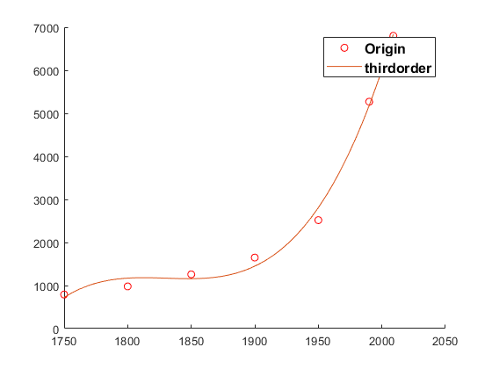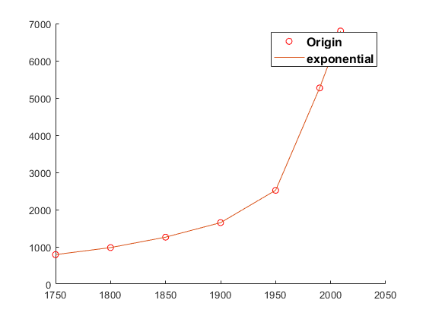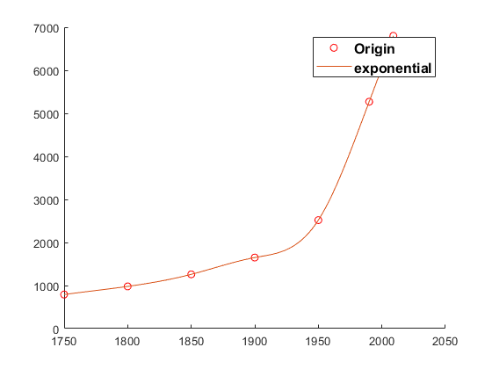

Problem 5
Script
clear all;
clc;

Function=@(x)3*x(1)^4-2*x(1)^2+4*x(1)+1+x(2)^2-x(2);
[x1,min]=fminsearch(Function,[-5,-5])
x1=-1:0.01:-0.5;
range_x2=0:0.01:1;
[x1,x2]=meshgrid(x1,range_x2);
Y = 3*x1.^4-2*x1.^2+4*x1+1+x2.^2-x2;
mesh(x1,x2,Y)

Result
x = -0.8514 0.5000
min = -2.5290
Graph
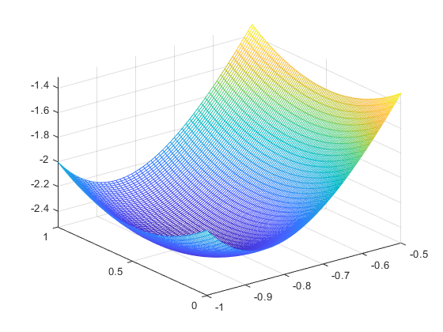

Problem Bonus
Script
clear
clc
clc
format compact

Function = @(x)x^2*cos(2*pi*x);
[x0,y0] = fminbnd(Function,0,1)
fplot(Function,[-1 1])
hold on
plot(x0,y0,'o')
plot(-x0,y0,'o')

Result
x0= ±0.5799
y0= -0.2948
Graph
